How to submit a Tank Warranty Claim
It’s Easy as 1,2,3
Step 1 After you are logged in, click on My Account (Your Account Won’t be My Name)
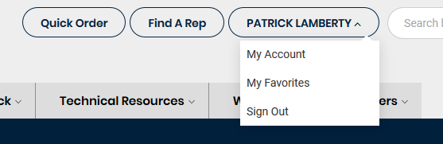
Step 2 Click on Warranty Request
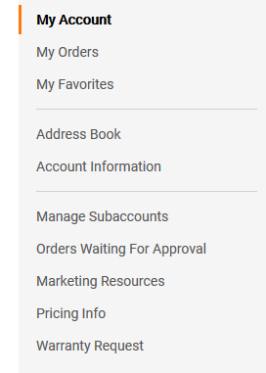
Step 3 Select Appropriate Tank Category and complete Form
*****We must receive ratings label off failed tank (NO PICTURES) removed and scanned will be accepted and BOCK replacement serial number before credit can be processed. *****

